Line-by-Line: How the Agent Code Actually Works
Every function explained, every library choice justified

0. The Loop You Already Know, Mapped to Code
You know this diagram already — a Query comes in, the model has a Thought, the Thought triggers an Action (call a tool), the Tool returns an Observation, and that feeds a new Thought. It keeps going until the Thought is confident enough to give a final Answer.
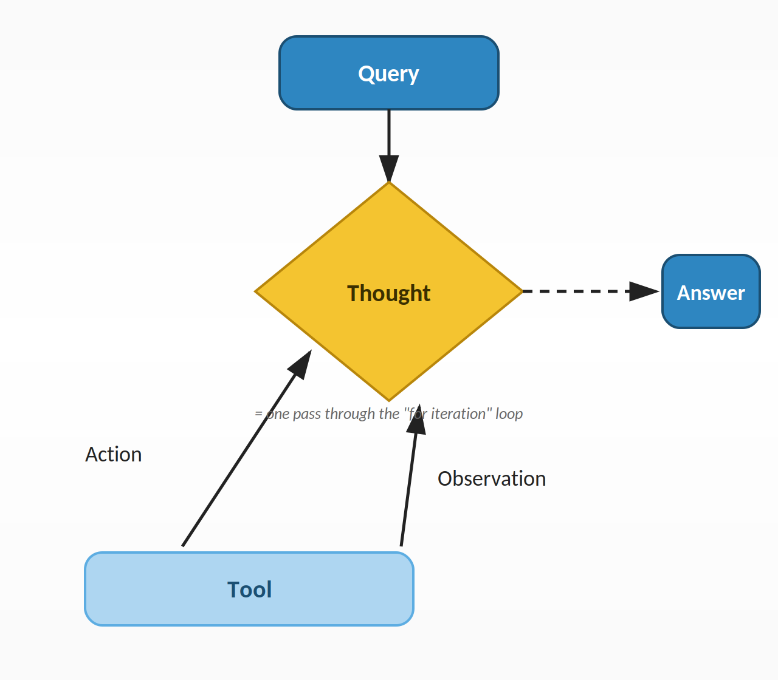
This entire loop is ONE pass through the "for iteration" loop in the code. Every box below maps to a specific line.
Here is the mapping, so you can hold this picture in your head while reading code:
- Query → the question string passed into run_agent(question)
- Thought → the LLM call itself: llm_with_tools.invoke(messages) or ollama.chat(...)
- Action → reading ai_message.tool_calls to see which tool + which arguments the model picked
- Tool → actually running that Python function: tool_to_use.invoke(tool_args)
- Observation → the return value of that function, wrapped and appended back into messages as a ToolMessage
- Answer → the moment tool_calls is empty, ai_message.content is returned

1. File 1 — LangChain Version, Every Line

1.1 Imports — why each one is there
from dotenv import load_dotenv
load_dotenv()
Nothing to do with agents. This just reads a .env file in your project folder and loads its contents as environment variables — almost certainly API keys (LangSmith key, maybe an OpenAI key). It has to run before you import anything that needs those keys, which is why it's the very first line.
from langchain.chat_models import init_chat_model
from langchain.tools import tool
from langchain_core.messages import HumanMessage, SystemMessage, ToolMessage
from langsmith import traceable
Four separate imports doing four separate jobs:
- init_chat_model — a single function that can load a chat model from any supported provider (OpenAI, Anthropic, Ollama, Google...) by reading a "provider:model_name" string. Why this instead of importing an Ollama-specific class directly? Because if you ever swap models — say from local Ollama to a hosted API — you change one string, not your whole codebase.
- tool — the decorator. Why a decorator and not, say, a wrapper class? Because a decorator lets you keep writing a completely normal Python function and just "tag" it as tool-usable, with zero change to how you'd call it yourself elsewhere.
- HumanMessage, SystemMessage, ToolMessage — typed containers for the three kinds of entries that go in your conversation history. LangChain uses classes here instead of plain dicts so that your editor/IDE can catch typos (e.g. it knows ToolMessage needs a tool_call_id, a plain dict wouldn't warn you if you forgot it).
- traceable — from langsmith, a completely separate concern: logging. It has nothing to do with how the agent thinks; it only records what happened so you can inspect it later in a dashboard.

1.2 Why turn get_product_price and apply_discount into functions at all?
@tool
def get_product_price(product: str) -> float:
"""Look up the price of a product in the catalog."""
prices = {"laptop": 1299.9, "headphones": 149.95, "keyboard": 89.50}
return prices.get(product, 0)
This is probably your real question, so slowing down here: an LLM cannot look inside your database, your files, or your business logic — it only knows the text you show it. A "tool" is simply a bridge: a real, deterministic, testable Python function that CAN do those things, which you hand to the model so it can ask you to run it on its behalf.
Why a function specifically, and not e.g. a string of instructions?
- A function is callable — once the model tells you its name and arguments, you literally run it: tool_to_use.invoke(args). There's no ambiguity about "how" to execute it.
- A function's signature (product: str) and docstring double as documentation the @tool decorator can read automatically, to build the schema the LLM sees. You get free documentation and free execution from one piece of code.
- It keeps the LLM out of your business logic entirely. The model never sees your prices dictionary or your discount formula — it only ever sees the function's name, description, and return value. This is safer (no hallucinated prices) and easier to test (you can unit-test get_product_price completely independently of any LLM).
Rule of thumb: if the LLM needs a fact or a calculation it cannot possibly know from training data alone (today's prices, your database, live weather, exact math), that becomes a tool — a normal function, decorated so the model can request it.
prices = {"laptop": 1299.9, "headphones": 149.95, "keyboard": 89.50}
return prices.get(product, 0)
Just a plain Python dictionary standing in for a real database or API call. .get(product, 0) returns 0 if the product isn't found instead of crashing — a small defensive habit worth keeping.
@tool
def apply_discount(price: float, discount_tier: str) -> float:
"""Apply a discount tier to a price and return the first price.
Available tiers: bronze, silver, gold."""
Same pattern, second tool. Notice the docstring explicitly lists the valid tiers ("bronze, silver, gold") — that's not just for humans reading the code, it's part of what the LLM reads to know what values are legal to pass in.

1.3 Setting up the agent loop function
@traceable(name="LangChain Agent Loop")
def run_agent(question: str):
Why wrap the whole agent in a function at all? Two reasons. First, reusability — you can call run_agent("different question") as many times as you like without rewriting logic. Second, @traceable needs a function boundary to know where one "agent run" starts and ends in the LangSmith dashboard — if this weren't a function, there'd be nothing to attach the tracer to.
tools = [get_product_price, apply_discount]
tools_dict = {t.name: t for t in tools}
Two different shapes of the same list, kept for two different purposes: tools (a plain list) gets handed to the model so it knows what's available. tools_dict (a name → function lookup table) is for YOUR code later — when the model says "call get_product_price", you need to go from that string name back to the actual callable function fast, without looping through a list every time. t.name works because @tool automatically gives every decorated function a .name attribute equal to its function name.
llm = init_chat_model(f"ollama:{model}", temperature=0)
llm_with_tools = llm.bind_tools(tools)
Two separate steps on purpose. init_chat_model() only loads and configures the model — temperature=0 means "always pick the most likely next word, don't be random/creative," which you want for an agent since you need consistent, predictable tool-calling behaviour, not creative writing. .bind_tools(tools) is a second, separate step that returns a NEW model object aware of your tools. Why keep llm (no tools) around at all instead of overwriting it? In bigger projects you sometimes want the same base model with different tool sets for different tasks — keeping them separate makes that possible.

1.4 Building the starting conversation
messages = [
SystemMessage(content=(...)),
HumanMessage(content=question),
]
This list is the ENTIRE memory of the conversation — the model has no memory of its own between calls, so everything it needs to know has to be re-sent every single time. SystemMessage goes first because it sets the ground rules ("never guess a price", "always use apply_discount") — the model treats system-role text as instructions to follow, distinct from the user's actual question, which is why it's a different message type instead of just being glued onto the question text.

1.5 The loop itself, line by line
for iterations in range(1, MAX_Iterations + 1):
Why a loop with a maximum, instead of "while True"? Safety. If the model gets stuck in a bad pattern (e.g. keeps calling a tool that keeps failing), an infinite loop would hang your program and burn API calls forever. Capping it at 10 guarantees the function always eventually returns, even in the worst case.
ai_message = llm_with_tools.invoke(messages)
This is the "Thought" step from your diagram. The ENTIRE messages list built so far is sent to the model, and it replies with one new message — which might be plain text, or might be a request to call a tool.
tool_calls = ai_message.tool_calls
if not tool_calls:
print(f"\nFinal Answers: {ai_message.content}")
return ai_message.content
This is the loop's only exit condition. tool_calls is a list — LangChain always gives you a list even if there's only one call, because some models can request multiple tools at once. Empty list = the model decided it has enough information and just wrote a normal answer in .content, so we return it immediately and the function ends here.
tool_call = tool_calls[0]
tool_name = tool_call.get("name")
tool_args = tool_call.get("args", {})
tool_call_id = tool_call.get("id")
Why [0] and a comment saying "force one tool per iteration"? Even if the model asked for two tools at once, this code deliberately only processes the first one, runs the loop again, and lets the model ask for the next one on the following iteration. This is a simplicity choice — handling multiple simultaneous tool calls correctly is more complex (you'd need to run each one and attach each result to its own tool_call_id), so this version trades a bit of speed for much simpler code. Each of these three lines pulls one piece of the model's request out of the dictionary it returned: which function, with what arguments, tagged with which ID (needed later to match the result back up).
tool_to_use = tools_dict.get(tool_name)
if tool_to_use is None:
raise ValueError(f"Tool '{tool_name}' not found")
A safety check. Normally the model can only ask for tools you gave it, but defensive code assumes the unexpected can happen (a bug, a model hallucinating a tool name that doesn't exist) — better to fail loudly with a clear error than to silently continue with a broken state.
observation = tool_to_use.invoke(tool_args)
This is the "Action" step — the real Python function actually runs here, with the exact arguments the model specified. .invoke() is used (instead of just calling tool_to_use(**tool_args) directly) because @tool wraps your function in a LangChain "Runnable" object — invoke() is the consistent method name LangChain uses everywhere, for models AND tools AND chains, so once you learn it, it works the same way throughout the whole library.
messages.append(ai_message)
messages.append(ToolMessage(content=str(observation), tool_call_id=tool_call_id))
This is the "Observation" step — feeding the result back in. Two messages get appended, not one: first the model's own request (so the conversation history correctly shows "I asked for this tool"), then the tool's result. tool_call_id is what lets the model correctly match this particular result to that particular request, especially important if it ever asks for multiple tools across a conversation. str(observation) converts the returned number/value into text, since messages are text-based.
Then the for loop goes back to the top and calls llm_with_tools.invoke(messages) again — except now messages is longer, so the model can see everything that happened so far and decide the next step.

2. File 2 — Same Loop, Why Remove LangChain?
The point of this file is educational: to prove LangChain isn't doing anything magical — it's automating work you CAN do by hand. Removing it shows you exactly what that work looks like.

2.1 The import that changes everything
import ollama
Instead of LangChain's provider-agnostic init_chat_model(), this imports Ollama's own official Python package directly. Why would you ever choose this over LangChain? If you know for certain you'll only ever use Ollama, and you don't need LangChain's other features (chains, memory helpers, provider-switching), talking to the client directly means one less layer of abstraction — fewer library version conflicts, slightly faster, easier to see exactly what's being sent over the wire. The tradeoff: if you ever want to switch to OpenAI or Anthropic, you rewrite this file from scratch.

2.2 Why write the JSON schema by hand?
tools_for_llm = [
{ "type": "function", "function": { "name": "get_product_price",
"description": "Look up the price of a product in the catalog.",
"parameters": { "type": "object",
"properties": { "product": { "type": "string", "description": "..." } },
"required": ["product"] } } },
...
]
This dictionary is exactly what @tool was building for you automatically in File 1, by reading your function's type hints and docstring. Here there is no decorator doing that reading, so you write the same structure by hand. This is the OpenAI-style "function calling" JSON schema format — most LLM providers that support tool calling (OpenAI, Ollama, many others) expect roughly this shape: a name, a description, and a parameters object following JSON Schema rules (type, properties, required).
Why go through this pain at all, instead of just describing the tool in a sentence? Because a strict, predictable schema is what lets the model return strictly structured output back (a real JSON object with exact argument names) instead of loose text you'd have to guess at. This one dictionary is the entire reason File 2 doesn't need regex parsing the way File 3 does.

2.3 The traced Ollama call — why a helper function?
@traceable(name="Ollama Chat", run_type="llm")
def ollama_chat_traced(messages):
return ollama.chat(model=MODEL, tools=tools_for_llm, messages=messages)
Why wrap a one-line call in its own function instead of just calling ollama.chat() directly inside the loop? Because @traceable can only log a function call as a distinct step if it IS a function call. In File 1, LangChain's own .invoke() was already automatically wired up to log itself to LangSmith — here, since you're bypassing LangChain, you have to manually create a function purely so there's something for @traceable to attach to and label "this was the LLM step."

2.4 The loop — what's identical, what's different
response = ollama_chat_traced(messages=messages)
ai_message = response.message
tool_calls = ai_message.tool_calls
Structurally identical to File 1's ai_message = llm_with_tools.invoke(messages) — same idea, different object shape. response.message is how the raw Ollama client structures its reply (a response object containing a message), versus LangChain's .invoke() which returns the message directly.
tool_name = tool_call.function.name
tool_args = tool_call.function.arguments
The single most important gotcha in this whole file: this is DOT access (.function.name) not dictionary access (.get("name")) like File 1 used. Ollama's raw client returns proper Python objects with attributes; LangChain's tool_calls returns plain dictionaries. Mixing these up (using .get() here, or ["name"] here) is the single most common copy-paste bug when moving between the two styles.
observation = tool_to_use(**tool_args)
Compare to File 1's tool_to_use.invoke(tool_args). Here tool_to_use is just a plain Python function (no @tool decorator, no LangChain wrapper), so you call it the plain Python way: **tool_args unpacks the dictionary {"product": "laptop"} into the keyword argument product="laptop". No .invoke() exists here because there's no LangChain Runnable object to provide that method.
messages.append(ai_message)
messages.append({"role": "tool", "content": str(observation)})
Same idea as File 1's messages.append(ToolMessage(...)) but written as a raw dictionary with a "role": "tool" key instead of a typed class — because there's no ToolMessage class imported here. This is literally what ToolMessage builds internally, just visible now instead of hidden.

3. File 3 — Why Remove Structured Tool Calling Entirely?
This file answers a different question: "what did agents look like before models had a built-in tools= parameter at all?" It's useful precisely because it's uncomfortable — you'll feel exactly how much native tool calling protects you from, once you see it done without that protection.

3.1 New imports and why they're needed now
import re
import inspect
Neither of these appeared in Files 1 or 2, because neither was needed: re (regular expressions) is only needed here because we now have to extract structured information (a tool name, its arguments) out of loose, free-form text the model writes — there is no tool_calls field to read anymore. inspect lets Python examine a function's own signature and docstring at runtime, used here to auto-generate a plain-English description of each tool for the prompt, since there's no @tool decorator doing that anymore either.

3.2 Building tool descriptions by hand, differently again
def get_tool_descriptions(tools_dict):
descriptions = []
for tool_name, tool_function in tools_dict.items():
original_function = getattr(tool_function, "__wrapped__", tool_function)
signature = inspect.signature(original_function)
docstring = inspect.getdoc(tool_function) or ""
descriptions.append(f"{tool_name}{signature} - {docstring}")
return "\n".join(descriptions)
Why a whole function instead of the hand-written JSON from File 2? Because here the "schema" is nothing more than a line of English text pasted into the prompt — there's no JSON structure to validate against, so it's built more loosely, by reading Python's own introspection tools. getattr(tool_function, "__wrapped__", tool_function) specifically unwraps the @traceable decorator first — decorators wrap your function in another function, and without this line, inspect.signature() would show the decorator's generic (*args, **kwargs) signature instead of your real one (price, discount_tier).

3.3 The prompt IS the program
react_prompt = f"""
...
Use the following format:
Question: the input question you must answer
Thought: you should always think about what to do
Action: the action to take, should be one of [{tool_names}]
Action Input: the input to the action, as comma separated values
Observation: the result of the action
...
Final Answer: the final answer to the original input question
Begin!
Question: {{question}}
Thought:"""
Why does this work at all, with no code enforcing the format? It works because the model was trained on huge amounts of text following exactly this Thought/Action/Observation pattern (this format is famous — it's the original 2022 "ReAct" paper's prompt template) — so a capable model recognises the pattern and continues it naturally, the same way it would continue any other familiar structure. It's not guaranteed, just statistically very likely — which is exactly why this approach is fragile.
Notice the prompt ends with the literal word "Thought:" and nothing after it — this is a deliberate trick to bias the model into immediately continuing in the Thought/Action format rather than starting fresh.

3.4 Stopping the model from faking its own tool result
response = ollama_chat_traced(
model=MODEL, messages=[{"role": "user", "content": full_prompt}],
options={"stop": ["\nObservation"], "temperature": 0},
)
Why is this stop option so important here specifically, when Files 1 and 2 didn't need it? Because in this file, nothing stops the model from writing the ENTIRE conversation itself — including a made-up, hallucinated "Observation:" line with a fake tool result — since it's just generating free text. The stop parameter forcibly cuts the model off the instant it types "\nObservation", guaranteeing your code — not the model — gets to decide what the real observation is, using the real function's real return value.

3.5 Regex parsing — the fragile part
final_answer_match = re.search(r"Final Answer:\s*(.+)", output)
if final_answer_match:
final_answer = final_answer_match.group(1).strip()
return final_answer
re.search looks for the literal text "Final Answer:" anywhere in the model's output and captures whatever comes after it. \s* means "zero or more spaces," (.+) means "capture everything after that." If the model ever writes "final answer:" in lowercase, or "My Final Answer:", this simply fails to match — silently, with no error — which is the core weakness File 1 and 2 don't have, because they never depend on exact text phrasing.
action_match = re.search(r"Action:\s*(.+)", output)
action_input_match = re.search(r"Action Input:\s*(.+)", output)
if not action_match or not action_input_match:
break
Same idea for the tool-call step. If neither "Final Answer:" nor "Action:" is found, the code has no idea what the model wants — so it just breaks out of the loop entirely rather than guessing. This is the fragility File 1/2's tool_calls field was specifically invented by model providers to eliminate.
raw_args = [x.strip() for x in tool_input_raw.split(",")]
args = [x.split("=", 1)[-1].strip().strip("'\"") for x in raw_args]
Splitting arguments by comma, since the prompt told the model to format them as "comma separated values" — this is a hand-rolled, simplified parser: it splits on every comma (which would break on a value that itself contains a comma), and strips off any key= prefix and quote marks the model might have added. Compare this to File 1/2 where tool_args arrives as an already-correct dictionary — no parsing needed at all, because the provider guarantees the structure.
observation = tools[tool_name](*args)
*args unpacks the parsed list positionally (not by keyword name, unlike File 2's **tool_args) — because regex parsing only gave us a plain list of string values in order, not a labelled dictionary. This is a smaller, subtler downside: if the model lists the arguments in the wrong order, this silently passes the wrong value to the wrong parameter, whereas File 1/2's keyword-based calling would at least fail with a clear "unexpected keyword" error.
scratchpad += f"{output}\nObservation: {observation}\nThought:"
This replaces messages.append(...) from Files 1/2. Instead of a structured list of message objects, the entire conversation history here is just one giant growing string, re-sent in full every iteration (full_prompt = prompt + scratchpad). It works, but you lose all the structure (roles, IDs, types) that made Files 1 and 2 easy to reason about and debug.

4. Why These Particular Libraries, Overall

LangChain (File 1) — chosen when you want to move fast, support multiple model providers without rewriting code, and get tool schemas generated for you. The cost is one more dependency and one more layer to understand.
Raw Ollama client (File 2) — chosen when you're committed to Ollama specifically, want fewer dependencies, or want to see/control exactly what's sent to the model. The cost is you rewrite this integration work for every provider you might use later.
Plain prompting + regex (File 3) — essentially never chosen for new projects today. It exists in your course to show you the historical technique native tool calling replaced, and to make you appreciate why tool_calls being a guaranteed, structured field (Files 1 & 2) is such a big deal.
langsmith (@traceable, all three files) — purely observability. Chosen because debugging "why did my agent call the wrong tool" from print statements alone gets painful fast; a trace dashboard lets you see the exact prompt, exact response, and exact tool result for every step, after the fact.
dotenv (load_dotenv, all three files) — chosen so API keys and secrets live in a local .env file (never committed to git) instead of hard-coded in your source code — a basic security habit, unrelated to the agent logic itself.

